ULTRASONIC THICKNESS MEASUREMENT REPORT
Company/Client |  | NCOC N. V. |  | Project |  | Eskene West Karabatan |  | Location |  | OSF
Line No/Tag No: |  | M2-334-TZ-001 |  | Material |  | S235 / S355 |  | Día × Nominal Thickness |  | -
Procedure No: |  | QP-11-UTT-Q01 Rev 02  GOST 28702-90 |  | Calibration Block |  | CS Step wedge |  | Probe  S/N |  | D 7906-SM  1040658
 |  |  |  | Calibration block Range |  | 6.25-25 mm |  | Angle |  | 0º
Manufacturing Code |  | ASME SEC VIII |  | Calibration Temp |  | +5º |  | Frequency |  | 5 MHz
 |  |  |  | Object Temp |  | +5º |  | Size |  | 11 mm
Acceptance Standard: |  | Acc. to the client specif. |  | Correction factors |  | n/a |  | Crystal |  | Dual
Surface condition |  | Coated |  | Couplant |  | UT Gel |  | Accuracy |  | ± 0,1 mm
S. No | Equipment/  Material Name |  | Manufacturer |  | Serial No |  | Calibration certificate No |  | Calibration Expiry date
 | A-scan UT |  | OLYMPUS DL-38 |  | 171421601 |  | BK-01-0552 |  | 02-04-2019
 | Step wedge calibration block |  | NDE Tech |  | NDE-8363 |  | - |  | 09.05.2019
Job description:
- UT spot check performed on PAUT low thickness measurement area of M2-334-TZ-001 of Row A1 Location 9.
- Inspection performed from external side and measurement was done through protection coat.

Legend:
FSH: Full Screen Height, N/A: Not Applicable

DETAILS AND RESULTS
M2-334-TZ-001
SOUTH (Row A-I Location 9)
Loc 2
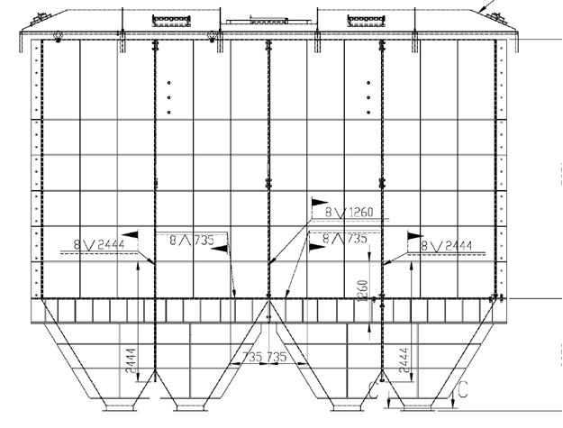
9

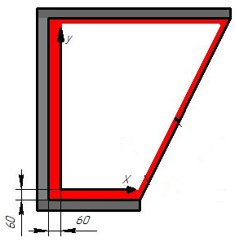
Loc 1

Location | Line No | Item description | Nominal thickness, mm | Minimum thickness, mm | Maximum thickness, mm | Average thickness, mm
Loc 1 | M2-334-TZ-001 | SOUTH Row A-I-9 | - | 3.46 | 4.50 | 3.96
Loc 2 | M2-334-TZ-001 | SOUTH Row A-I-9 | - | 3.86 | 4.62 | 4.12

Examined by  UT Level III cert. No 300400 | Name: Kishore kumar.P  expiry date: 30.03.2023 | Signature: ........................... | Date: 29 Nov 2018
Approved by  UT Level III cert. No 2B 189/16 | Name: Klindukhou Viachaslau  expiry date 31.05.2021 | Signature: ........................... | Date: 29 Nov 2018
Client Representative: | ………………………….…. | Signature: ........................... | Date: ...........................

